Summer Teachers Institute
Women in the Holocaust
August 5-7, 2019

APPLICATION FORM
Registration is $25
Make checks payable to: Jewish Museum of Maryland
Please note that the registration fee is non-refundable.

Name/Position

Grade/Class you teach
(if applicable)

School Name/district

Home address

City State Zip Code

Home Phone number Cell Phone number

Have you attend other workshops sponsored by the Jewish Museum of Maryland or the Baltimore Jewish Council? Please indicate which ones/years. We would also like to know how you heard about this program.

Which days do you plan on attending?

____ August 5 (Mon) ____ August 6 (Tues) ____ August 7 (Weds)

Please include email address(es) where you can be reached during the year as well as over the summer.

School Year email address:

Summer email address:

Please return applications and checks to:
Jewish Museum of Maryland
15 Lloyd Street
Baltimore, MD 21202, Attn: Summer Teachers Institute
For more information contact:
STI@jewishmuseummd.org
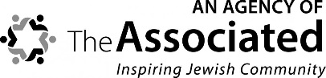
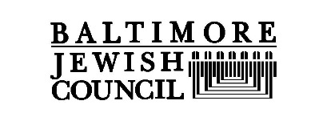
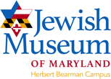
Accommodations for individuals with disabilities will be made upon request.
